Lecture 1, CIS 2336

Introduction, Syllabus, Schedule

<http://www.w3schools.com/> great website to learn HTML, CSS and Java Script

<http://freevideolectures.com/blog/2011/07/mobile-application-development-courses/>

<http://www.codecademy.com/learn> This is our learning and grading tool

Go Catalog. We would need

1. Learn HTML

2. Learn CSS

3. Introduction to Java Script

4. Make a website

5. Learn SQL

Start with completing profile (will be graded)

After completing First lesson, you will receive a badge

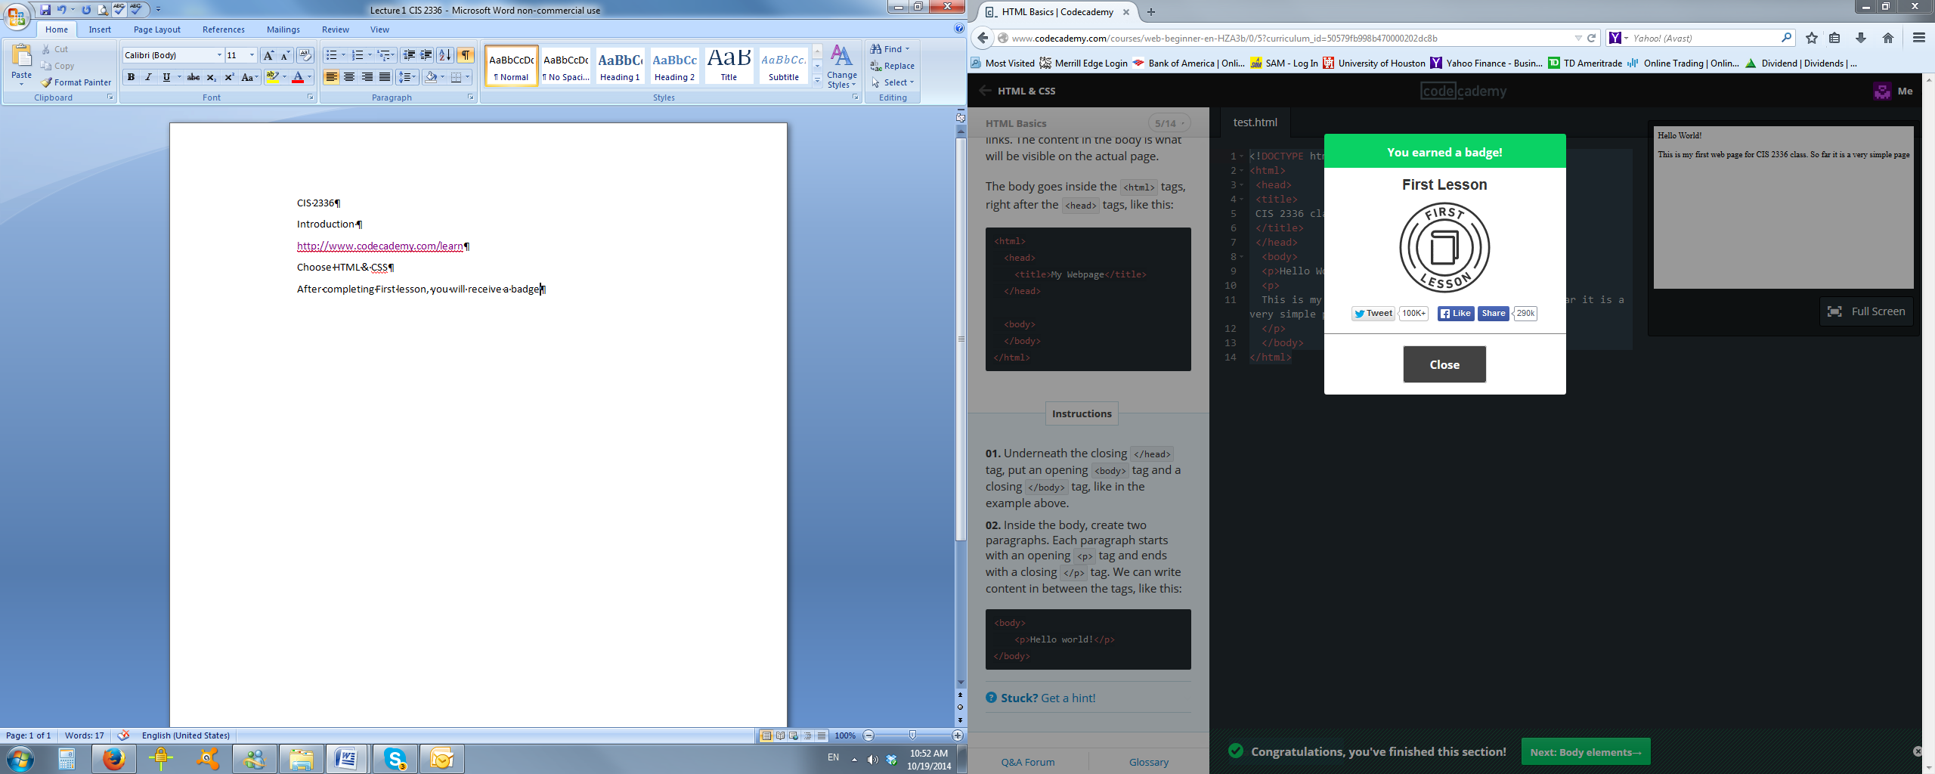

Complete all of them (Hint: to use picture from internet, click “Copy Image Location”)

Main idea of this course is to create On-line portfolio and post it as a website to real internet using Hostgator. Find Portfolio instructions and rubrics on Blackboard

Examples:

<http://vsmith.heyuhnem.com/>; <http://wsandhu.heyuhnem.com/>; <http://bufordb18s.heyuhnem.com/>;

We are not ready to create final portfolio, but we can start preparing items for it.

After completing your first assignment, start creating portfolio including following:

1. All your badges as a link:

[**http://www.codecademy.com/users/nfofanova/achievements**](http://www.codecademy.com/users/nfofanova/achievements)

1. First web page and its HTML code. In Final Portfolio this website will be just a link to your “My first webpage”

Name it as index.html and create similar to mine

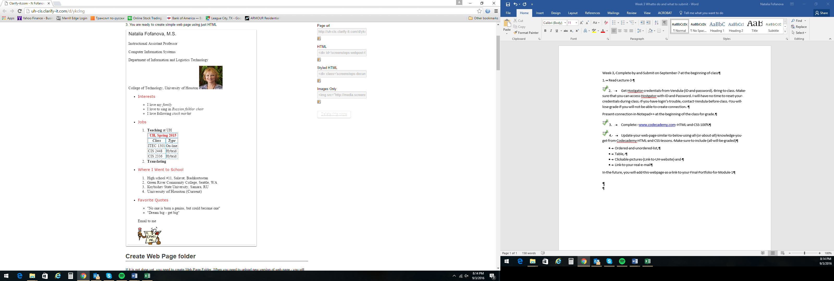

Make sure to include (all will be graded)

* Ordered and unordered list,
* Table,
* Clickable pictures (Link to UH website) and
* Link to your real e-mail
* E-mail image should be animated

Entire webpage should use ALL your knowledge from Learn HTML and Learn CSS module

Due to huge number of students in then class – I will not grade any activity during class, but expect that all is completed on time

**Introduction to HTML code**

<!Doctype>

<html>

<head> Portfolio Part 1: HTML

<title>

CIS 2336 Final pertfolio

</title>

</head>

<body>

<h1> Portfolio CIS 2336 <a href="nfofanov@Central.UH.EDU"> Natalia Fofanova </a></h1>

<h2>

<p> I have completed 13 lessons of learning HTML.I learned Structure of HTML language, syntax and TAGs. I can create simple web page and complicated if I have to. I like what I am doing so far.</p>

<img src="http://makethingsdostuff.co.uk/sites/default/files/styles/project/public/project/HTML_0.jpg?itok=DwqFIKP1">

<p> This is my final attempt to create web page using pure HTML code. I am CIS 2336 student, <a href="http://www.uh.edu/technology/">College of Technology</a></p>

<p>My instructor requiring to submit web page using on-line portfolio</p>

</h2>

</body>

</html>

**Introduction to HTML link and printscreen**

<http://www.codecademy.com/courses/web-beginner-en-LceTK/0/6?curriculum_id=50579fb998b470000202dc8b>

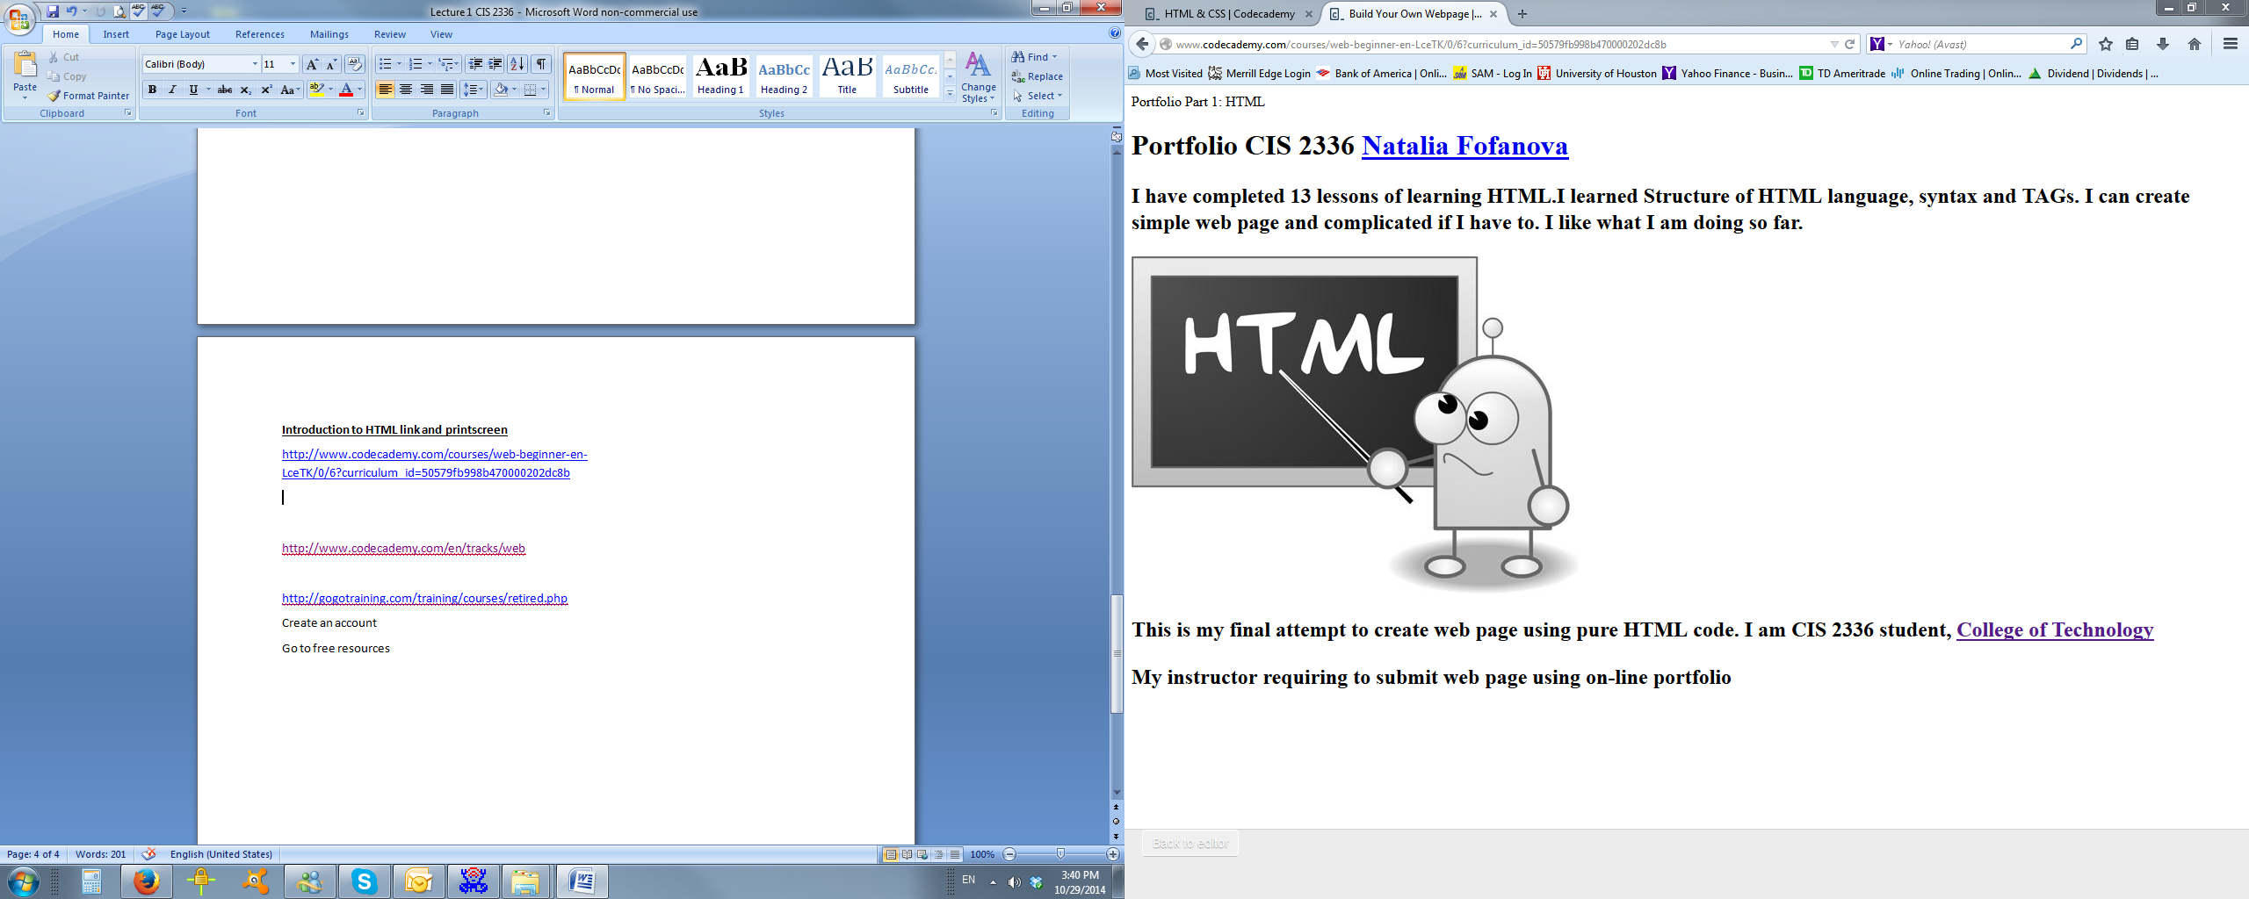

Create Portfolio for Part 1.2: HTML structure, Using List

<!DOCTYPE html>

<html>

<head>Portfolio CIS 2336 Natalia Fofanova

<title></title>

</head>

<body>

<h1>In this lesson, I will learn:</h1>

<ol>

<li>Making ordered and unordered lists</li>

<li>Changing font size, color and type</li>

<li>Changing the background color</li>

<li>Aligning the text</li>

</ol>

<h2> There is example</h2>

<ol>

<li>One</li>

<li>Two</li>

<li>Three</li>

</ol>

</body>

</html>

<!DOCTYPE html>

<html>

<head>

<title>Nested lists</title>

</head>

<body>

<ol>

<li>Dad's interests

<ul>

<li>football</li>

<li>knitting</li>

</ul>

</li>

<li>Mom's interests

<ul>

<li>hating football</li>

<li>skydiving</li>

</ul>

</li>

</ol>

<ul> <li>My favorite boys names

<ol>

<li> Vladimir</li>

<li>Viacheslav</li>

</ol>

</li>

<li>My favorite girls names</li>

<ol>

<li> Natalia</li>

<li>Tatiana</li>

</ol></ul>

</body>

</html>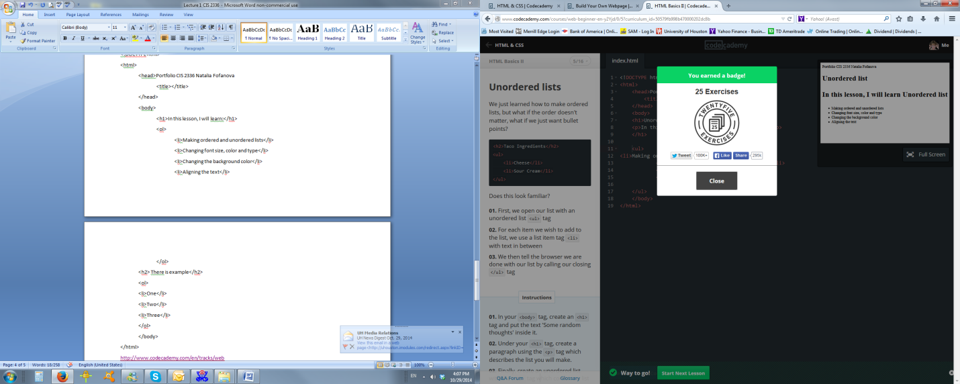

<!DOCTYPE html>

<html>

<head>

<title>Changing the colors!</title>

</head>

<body>

<h1 style="color:green; font-size: 16px">Big Heading</h1>

<p style="color:violet; font-size 10px">A giant bear and a little duck were friends.</p>

<h2 style="color:red; font-size 10px">But the bear got hungry and ate the duck.</h2>

</body>

</html>

<http://www.codecademy.com/en/tracks/web>

<http://gogotraining.com/training/courses/retired.php>

Create an account

Go to free resources

<!DOCTYPE html>

<html>

<head>

<style>

p {

color: purple;

}

</style>

<link type="text/css" rel="stylesheet" href="stylesheet.css" />

<title>Natalia Fofanova</title>

</head>

<body>

<p style="font-size: 20; font-family:Arial">Natalia Fofanova, M.S.

<p>Instructional Assistant Professor

<p>Computer Information Systems

<p>Department of Information and Logistics Technology

<p>College of Technology, University of Houston

</P>

<img src="http://faculty.tech.uh.edu/fofanova/files/2014/06/fofanova-natalia.jpg" />

<ul>

<li><p style="color:red; font-family:Verdana">Interests</p>

<ul>

<li style="font-family:Futura">I love my <em>family</li>

<li style="font-family:Futura">I love to sing in <em>Russian folklor choir</em></li>

<li style="font-family:Futura">I love following <em>stock market</em></li>

</ul>

</li>

<li><p style="color:red; font-family:Verdana">Jobs</p>

<ol>

<li style="font-family:Futura"><strong>Teaching </strong>at UH

<table border="1px">

<thead>

<tr>

<th colspan="3"; style="font-size: 16px; color:red">UH, Spring 2015</th>

</tr>

<tr>

<th>

<em>Class</em>

</th>

<th>

<em>Type</em>

</th>

<th>

<em>Time</em>

</th>

</tr>

</thead>

<tbody>

<tr><td>ITEC 1301</td><td>On-line</td><td>On-line</td> </tr>

<tr> <td>CIS 2448</td><td>Hybrid</td><td>Wed, 4:00-7:00</td> </tr>

<tr> <td>CIS 2336</td><td>Hybrid</td><td>Wed, 1:00-4:00</td> </tr>

</tbody>

</table>

</li>

<li style="font-family:Futura"><strong>Translating</li>

</ol>

</li>

<li><p style="color:red; font-family:Verdana">Where I Went to School</p>

<ol>

<li style="font-family:Futura">High school #11, Salavat, Bashkortostan</li>

<li style="font-family:Futura">Green River Community College, Seattle, WA</li>

<li style="font-family:Futura">Kuybishev State University, Samara, RU</li>

<li style="font-size:18px; font-family:Futura">University of Houston (Current)</li>

</ol>

</li>

<li><p style="color:red; font-family:Verdana">Favorite Quotes</p>

<ul>

<li style="font-family:Futura">"No one is born a genius, but could become one"</li>

<li style="font-family:Futura">"Dream big - get big"</li>

</ul>

<p> Email to me</p>

<p><a href="mailto:nfofanova@comcast.net"><img src="https://encrypted-tbn3.gstatic.com/images?q=tbn:ANd9GcR91sy0L5YLLcbql5idq6iDSH023Ur-IVRkEub2LYo2e5wEHWQR" />

</body>

</html>

When table are pictures

<tbody>

<tr><td><a href="mailto:nfofanova@comcast.net"><img src="http://faculty.tech.uh.edu/fofanova/files/2014/06/fofanova-natalia.jpg" /></td><td><a href="mailto:nfofanova@comcast.net"><img src="http://faculty.tech.uh.edu/fofanova/files/2014/06/fofanova-natalia.jpg" /></td><td><a href="mailto:nfofanova@comcast.net"><img src="http://faculty.tech.uh.edu/fofanova/files/2014/06/fofanova-natalia.jpg" /></td> </tr>

<tr> <td><a href="mailto:nfofanova@comcast.net"><img src="http://faculty.tech.uh.edu/fofanova/files/2014/06/fofanova-natalia.jpg" /></td><td><a href="mailto:nfofanova@comcast.net"><img src="http://faculty.tech.uh.edu/fofanova/files/2014/06/fofanova-natalia.jpg" /></td><td><a href="mailto:nfofanova@comcast.net"><img src="http://faculty.tech.uh.edu/fofanova/files/2014/06/fofanova-natalia.jpg" /></td> </tr>

<tr> <td><a href="mailto:nfofanova@comcast.net"><img src="http://faculty.tech.uh.edu/fofanova/files/2014/06/fofanova-natalia.jpg" /></td><td><a href="mailto:nfofanova@comcast.net"><img src="http://faculty.tech.uh.edu/fofanova/files/2014/06/fofanova-natalia.jpg" /></td><td><a href="mailto:nfofanova@comcast.net"><img src="http://faculty.tech.uh.edu/fofanova/files/2014/06/fofanova-natalia.jpg" /></td> </tr>

</tbody>

CSS

/*All my H1 will be in Verdana, all my H3 will be with Courier, all my paragraphs will be purple*/

h1{

font-family: Verdana;

}

h3{

font-family: Courier;

}

p{

color: purple;

}

CSC examples

img {

display: block;

height: 100px;

width: 300px;

margin: auto;

}

p {

text-align: center;

font-family: Garamond, serif;

font-size: 18px;

}

div {

border-radius: 5px;

border: 2px solid #6495ED;

background-color: #BCD2EE;

height: 50px;

width: 120px;

margin: auto;

text-align: center;

}

a {

text-decoration: none;

color: #3D59AB;

font-family: Verdana, sans-serif;

}

span {

font-weight: bold;

font-size: 18px;

color: #ffffff;

}

*

{

border: 1px dashed #3A5FCD;

} iv {

border-radius: 5px;

border: 2px solid #6495ED;

background-color: #BCD2EE;

height: 18px;

text-align: center;

font-family: Garamond, serif;

}

#p1 {

display: inline;

position: relative;

margin-left: 138px;

}

#p2 {

display: inline;

position: relative;

margin-left: 10px;

}

#p3 {

display: inline;

position: relative;

margin-left: 10px;

}

#div {

display: inline;

position: relative;

margin-left: 70px;

margin-top: 10px;

}

#title {

display: inline;

position: relative;

margin-left: 50px;

}

#body {

display: inline;

position: relative;

margin-left: 25px;

}

#head {

display: inline;

position: relative;

margin-left: 65px;

}

#html {

width: 50px;

position: relative;

margin-left: 93px;

}

.space {

opacity: 0;

}

